|  |
| --- |
| José Coronil Álvarez (joscoralv@alum.us.es)  Miguel García Vizcaíno (miggarviz@alum.us.es)  Javier Ignacio Milá de la Roca Dos Santos (javmildos@alum.us.es)  Emilio Manuel Vázquez Cruz (emivazcru@alum.us.es)  C1.028  2-18-2025 |

|  |
| --- |
| Acme AirNav Solutions, Inc. |
| **Chartering Report** |
| https://github.com/Emilio-115/DP2-Acme-ANS |



**Contents**

Executive Summary 2

Revision Table 2

Introduction 3

Members Recruitment 4

Members Contact Data 5

Agreement 5

Performance Indicators 6

Firing Conditions 6

Conclusions 7

Bibliography 7

# Executive Summary

This document outlines the recruitment process led by the first manager, Emilio Manuel Vázquez Cruz, to form the group. It provides the contact details of each member, including their picture, name, surname, and email. The team understands the course methodology and is committed to doing their best to achieve a final grade of 8.

The document explains the two metrics used to evaluate individual and group performance: “Done vs. Todo” and “Personal Rating vs. Lecturer Rating.” Additionally, members with good performance will be rewarded in various ways, while those with poor performance will receive warnings or, in the worst case, be expelled from the group.

# Revision Table

|  |  |  |
| --- | --- | --- |
| Revision number | Date | Description |
| 1 | 2-17-2025 | Initial version |
| 2 | 2-18-2025 | Corrections after first follow-up and added to the docs template- |
| 3 | 2-19-2025 | Orthographical correction |
| 4 | 2-20-2025 | Last corrections |

-

# Introduction

This document marks the starting point for the work team. It provides a history of the process followed to form the team, along with various objectives, agreements, and rules to which the team is committed.

The document main content begins with the "Member Recruitment" section, which describes the process followed by the manager to recruit the members. Following this, in the "Members Contact Data" section, contact information for each member is provided.

Next, in the "Agreement" section, the group's commitments to the project are outlined.

In the "Performance Indicators" section, the metrics used by the group to assess individual and group performance in various ways and across different aspects are described. Based on performance, members will either be rewarded or penalized.

Finally, the "Firing Conditions" are detailed.

# Members Recruitment

The group is composed of the following members: Emilio Manuel Vázquez Cruz, Javier Ignacio Milá de la Roca Dos Santos, José Coronil Alvarez and Miguel García Vizcaino. The group was already agreed upon before the recruitment forum was used, the thread of the forum in which the recruitment was announced was created by Emilio Manuel Vázquez Cruz on 2/7/2025 5:20 PM."

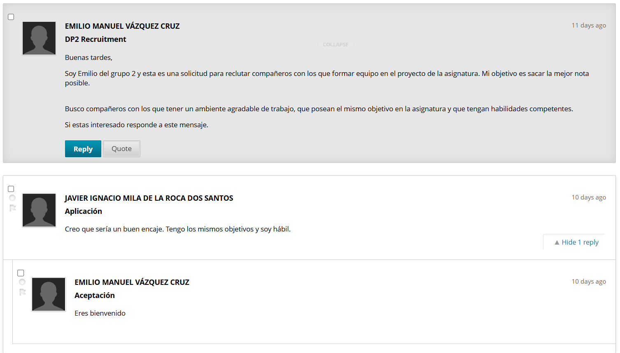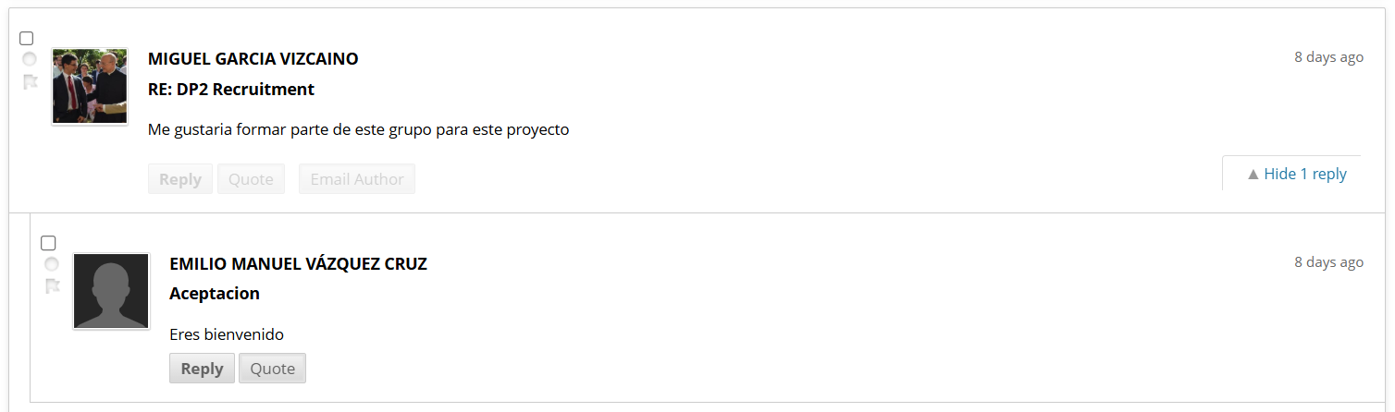 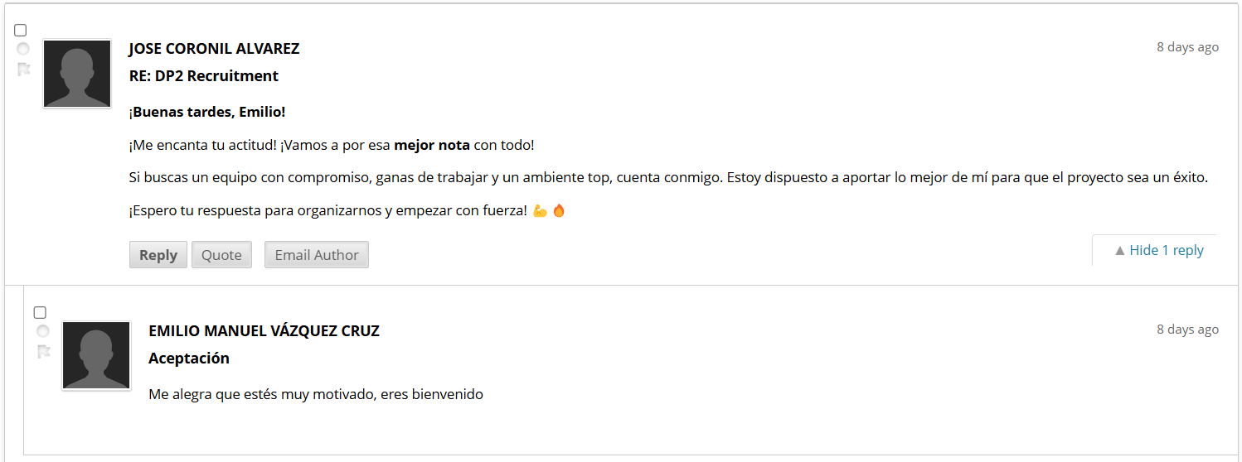

# Members Contact Data

|  |  |  |  |
| --- | --- | --- | --- |
| **Picture** | **Name** | **Surname** | **Email** |
|  | Emilio Manuel | Vázquez Cruz | [emivazcru@alum.us.es](mailto:emivazcru@alum.us.es) |
|  | Javier Ignacio | Milá de la Roca Dos Santos | [javmildos@alum.us.es](mailto:javmildos@alum.us.es) |
|  | José | Coronil Álvarez | [joscoralv@alum.us.es](mailto:joscoralv@alum.us.es) |
|  | Miguel | García Vizcaino | [miggarviz@alum.us.es](mailto:miggarviz@alum.us.es) |

# Agreement

As a group we commit to work collaboratively throughout the course, ensuring that all members are well-acquainted with the syllabus and fully understand the course's evaluation methodology, including the process for calculating grades. Moreover, the group is dedicated to complete the necessaries Supplementary I and II requirements in order to achieve a final grade of at least 8 in the course.

# Performance Indicators

**Done(D) vs TODO(TD):**

DTD = D/TD

Done work divided by work to be done. D is the work done in a week, and TD is the work planned to do in the week, if the result is lower than 0.8 the member is having a bad performance, in the last week if the result is not 1, the member had a poor performance during the Sprint.

It will be applied to each category of requirements (Mandatory, Supplementary I and Supplementary II).

**Personal rate (PR) vs Lecturer rate (LR):**

LRPR = LR/PR

This indicator compares our expectations with the final result. If lower than one the team/member is working worse than expected and if equal to one the team/member is working as expected. PR is the number of requirements expected to accomplish and LR is the number of requirements considered as accomplish by the lecturers in the follow-up sessions. To evaluate the team, the group requirements are used and to evaluate the member his individual requirements are used.

Members who perform well will be rewarded with public recognition, may be assigned leadership roles in future deliveries and, as a reward, they will be given a free donut. On the other hand, members with bad performance will not receive a free donut.

# Firing Conditions

Members who do not contribute to the group's mandatory requirements, fail to collaborate with the team, and act independently without considering the impact on others' work will first be warned. The performance will be measured based on the metrics provided earlier. If, in two consecutive deliveries, their weekly DTD metric for mandatory requirements is below 0.7, they may be expelled from the group. Members who consistently take on the work of others each week and, despite being warned, continue this behavior will be expelled from the group. For example, if members of the group are required to redo tasks every week due to the actions of one member, this could result in their expulsion from the group.

# Conclusions

In conclusion, our group was formed through a clear recruitment process, where each member was carefully chosen and agreed upon before the forum was even used. This initial step established the foundation for our collaborative efforts, setting the stage for a productive and harmonious working environment.

Moving forward, we are committed to achieving high performance through clear expectations and continuous evaluation. The metrics we've established, such as Done (D) vs. TODO (TD) and Personal Rate (PR) vs Lecturer’s Rate (LR), will help us track individual and group progress to ensure we meet the course's requirements and standards.

Members who demonstrate consistent effort and contribute positively to the group's work will be recognized and rewarded with opportunities for leadership roles and other forms of appreciation. However, those who fail to meet expectations, do not collaborate effectively, or consistently underperform will be given warnings. If their performance does not improve after two consecutive deliveries, expulsion from the group may occur.

Our success relies on accountability, support, and a commitment to excellence. By working together and staying focused on our collective goals, we will make our best effort to achieve the desired outcome of the course and secure a final grade of at least 8.

# Bibliography

Intentionally blank.

**Members’ signatures:**

Emilio Manuel Vázquez Cruz José Coronil Álvarez

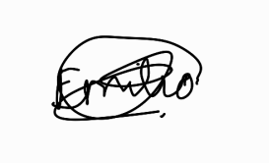 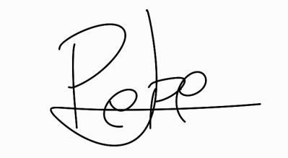

Javier Ignacio Milá de la Roca Dos Santos Miguel García Vizcaino

 